DEVELOPING A GAMING WEBSITE USING HTML AND CSS & JS

**A PROJECT REPORT**

***Submitted by***

# GUTHI BALA SRI CHARAN

***in partial fulfilment for the award of the degree*** ***of***

# BACHELOR OF TECHNOLOGY(CSE)



**Lovely Professional University, Punjab**

**Registration no: 12401339**

**OCT 2024**

**INDEX PAGE: -**

**TABLE OF CONTENTS**

|  |  |  |
| --- | --- | --- |
| **CHAPTER NO.** | **CHAPTER NAME** | **PAGE NO.** |
|  | **Title Page** | **1** |
|  | **Index Page** | **2** |
|  | **Introduction to project** | **3** |
|  | **Technology Used** | **3** |
|  | **Workflow** | **3** |
|  | **Working on the project** | **4** |
|  | **Code snippets of the project** | **5 - 30** |
|  | **Output Screenshots** | **30 -34** |
|  | **Conclusion** | **34** |
|  | **References** | **34** |
|  | **Git hub link** | **35** |

INTRODUCTION:

Creating a simple gaming website using HTML and CSS is a great way to start building user-friendly web interfaces! Below, I'll walk you through the basic structure for a gaming page. This will include an HTML form to collect customer details, styled with CSS for a clean, professional look.

* **HTML Form**: The form collects basic customer details, like username and email for login.

* **CSS Styling**: CSS provides a clean look with padding, background colour, rounded corners, and hover effects for buttons.

TECHNOLOGY USED:

Building a gaming website with HTML and CSS forms the front-end foundation. However, for a fully functional gaming system, additional technologies are typically used. Here’s an overview of the technologies commonly involved:

1. **HTML (Hypertext Markup Language)** 
   * **Purpose**: Structures the content of the gaming website.
   * **Usage**: Creates the form for user input fields like username and email.
2. **CSS (Cascading Style Sheets)** 
   * **Purpose**: Styles the website to make it visually appealing and user-friendly.
   * **Usage**: Designs the layout, colours, fonts, and adds interactivity (like hover effects on buttons)

WORKFLOW:

The workflow of a gaming website involves a sequence of interactions between the user interface (UI) and the backend. Here’s a breakdown of how the workflow typically proceeds, from when a user accesses the site to the gaming:

## 1. User Accesses the Website: -

➢ **Front-End (HTML & CSS)**: The user opens the gaming website, which loads the HTML and CSS files to display the game images.

## 2. User Can Fills Out the join Form: -

* **Front-End (HTML)**: The user enters their information in the form fields, selecting in which category the users are interested and also the country where they wants to work.
* **CSS**: Provides a polished, accessible design for easy data input.

WORKING ON PROJECT:

➢ A gaming website project is a great way to apply HTML and CSS skills, and it can be expanded to include JavaScript for interactivity and server side features if needed.

Here are some ideas to enhance the project:

1. **Responsive Design**: Make the form adapt to different screen sizes, so it

looks good on mobile and desktop.

1. **Interactive Features**: Consider using JavaScript to validate form inputs or

create a dynamic games picker.

1. **Styling Options**: You could try different CSS styles, such as adding animations or hover effects to buttons.

**Code snippets of the project:**

**Game.html**

**<!DOCTYPE html>**

**<html lang="en">**

**<head>**

**<title>Game</title>**

**<link rel="icon" type="icon/x-icon" href="ROYAL GAMES.png">**

**<link rel="stylesheet" href="Game.css">**

**</head>**

**<body>**

**<nav class="navbar"></nav>**

**<div class="navdiv">**

**<div class="logo"><a href="#">ROYAL GAMES</a></div>**

**<ul>**

**<li><button><a href="#">Home</a></button></li>**

**<li><button><a href="#">About</a></button></li>**

**<li><button><a href="#">Contact</a></button></li>**

**<li><button><a href="report.html">Report</a></button></li>**

**<button><a href="login.html">Login</a></button>**

**<button><a href="login2.html">SignUp</a></button>**

**</ul>**

**</div>**

**</nav>**

**<a href="https://poki.com/en/g/subway-surfers">**

**<img src="2nd image.jpg" height="150" width="130">**

**<a href="https://poki.com/en/g/temple-run-2">**

**<img src="3rd image.jpg" height="150">**

**<a href="https://poki.com/en/g/hill-climb-racing">**

**<img src="4th image.webp" height="150">**

**<a href="https://poki.com/en/g/sky-mad">**

**<img src="skymad.avif" height="150">**

**<a href="https://poki.com/en/g/stickman-hook">**

**<img src="stickmanhook.webp" height="150">**

**<a href="https://poki.com/en/g/ping-pong-go">**

**<img src="pingponggo.png" height="150">**

**<a href="https://poki.com/en/g/red-ball-4">**

**<img src="redball4.png" height="150">**

**<a href="https://poki.com/en/g/ludo-hero">**

**<img src="ludo.avif" height="150">**

**<a href="https://poki.com/en/g/2048">**

**<img src="2048.png" height="150">**

**<a href="https://poki.com/en/g/maze-path-of-light">**

**<img src="maze.avif" width="140" height="150">**

**<a href="https://poki.com/en/g/master-chess">**

**<img src="chess.avif" width="150" height="150"><br>**

**<a href="https://poki.com/en/g/fruit-ninja">**

**<img src="fruit.jpeg" height="150" width="130">**

**<a href="https://poki.com/en/g/jungle-friends">**

**<img src="jungle.jpeg" height="150" width="150">**

**<a href="https://poki.com/en/g/stick-merge">**

**<img src="Stickmerge.avif" height="150">**

**<a href="https://poki.com/en/g/stupid-zombies">**

**<img src="stupidzombies.png" height="150">**

**<a href="https://poki.com/en/g/escape-from-school">**

**<img src="Escape.png" height="150">**

**<a href="https://poki.com/en/g/venge-io">**

**<img src="venge.png" height="150">**

**<a href="https://poki.com/en/g/drive-mad">**

**<img src="Drivemad.jpeg" height="150">**

**<a href="https://poki.com/en/g/hide-and-seek-escape-games">**

**<img src="hide.png" height="150">**

**<a href="https://poki.com/en/g/soccer-skills-world-cup">**

**<img src="Soccer.jpeg" height="150">**

**<a href="https://poki.com/en/g/pool-club">**

**<img src="Pool.avif" height="150" width="140">**

**<a href="https://poki.com/en/g/rummy">**

**<img src="Rummy.png" height="150" width="150"></a><br>**

**<div class="outer-box">**

**<h3>Xbox</h3>**

**<div class="scroll-box">**

**<p>Global Connectivity: Players can connect with others from around the world, breaking down geographical barriers.</p>**

**<p>Diverse Genres: From action-packed shooters to relaxing farming simulations, there's something for everyone.</p>**

**<p>Skill Enhancement: Games can improve cognitive skills, such as strategic thinking and problem-solving.</p>**

**<p>Real-Time Updates: Developers constantly update games with new content, keeping the experience fresh.</p>**

**<p>Social Interaction: Many online games offer chat and voice communication, helping players make new friends.</p>**

**<p>Competitive Tournaments: Professional esports tournaments attract millions of viewers and offer substantial prize money.</p>**

**<p>Teamwork and Collaboration: Multiplayer games often require players to work together, fostering teamwork.</p>**

**<p>Accessible Entertainment: With devices ranging from smartphones to consoles, online games are easily accessible.</p>**

**<p>Creative Expression: Games like Minecraft allow players to express their creativity by building and designing.</p>**

**<p>Stress Relief: For many, playing games is a way to unwind and escape from daily stresses.</p>**

**<p>Educational Potential: Some games are designed specifically to teach skills or knowledge, from history to coding.</p>**

**<p>Virtual Economies: Many games have their own in-game economies, allowing players to trade, buy, and sell items.</p>**

**<p>Storytelling: Many online games offer deep and immersive stories, rivaling those of movies and books.</p>**

**<p>Customizability: Players often have the freedom to customize their characters and game environments, adding a personal touch.</p>**

**<p>Cross-Platform Play: Many games allow you to play with friends across different devices, from PCs to consoles to mobile.</p>**

**<p>Community Events: Online games often host special events or festivals that bring the community together.</p>**

**<p>Fitness and Health: Some games, like those on VR platforms, can provide physical exercise as part of the gaming experience.</p>**

**<p>Time Management: Games can help improve time management skills, especially those that require strategic planning.</p>**

**<p>Virtual Reality: VR games offer a fully immersive experience, making you feel like you are inside the game world.</p>**

**<p>Accessibility: Developers are increasingly making games accessible to people with disabilities, ensuring everyone can enjoy the fun.</p>**

**</div>**

**</div><hr>**

**<div class="dropdown">**

**<button class="dropbutton">Join Now</button>**

**<div class="Dropdown-content">**

**<a href="#">Click here</a><hr>**

**</div>**

**</div>**

**<div id="div1">**

**<form action="Your paragraph text.png" method="POST">**

**<h4>Freely inviting to became a member in our TEAM</h4>**

**<label for="name">Name:</label>**

**<input type="text" placeholder="Name here" name="name" required><hr>**

**<label for="email">Email</label>**

**<input type="email" placeholder="Email here" name="email" required><hr>**

**<select name="cities" id="cities">**

**<option value="Select">Select</option>**

**<option value="Adventure">Adventure</option>**

**<option value="Action">Action</option>**

**<option value="Casual">Casual</option>**

**<option value="Puzzle">Puzzle</option>**

**<option value="Simulation">Simulation</option>**

**<option value="Sports">Sports</option>**

**<option value="Strategy">Strategy</option>**

**</select><hr>**

**<label for="Why are you interested">Why are you interested:</label>**

**<textarea name="" id="address" cols="30" rows="5" name="address"></textarea><hr>**

**<input type="radio" value="INDIA" name="country"> INDIA**

**<input type="radio" value="USA" name="country"> USA**

**<input type="radio" value="CHINA" name="country"> CHINA**

**<input type="radio" value="CANADA" name="country"> CANADA**

**<input type="radio" value="JAPAN" name="country"> JAPAN**

**<hr>**

**<input type="submit" value="SUBMIT">**

**<input type="reset" value="RESET"><hr>**

**<p2>Note: If you select the <b>USA</b> you will be getting advantage </p2>**

**</form>**

**</div><hr>**

**<div id="wheel">**

**<p3>\/</p3>**

**<p4>8</p4><br>**

**<p5>musTang</p5>**

**</div>**

**<div id="div2">**

**<h2>Hover Table with Transitions</h2>**

**<table>**

**<tr>**

**<th>Heading 1</th>**

**<th>Heading 2</th>**

**<th>Heading 3</th>**

**</tr>**

**<tr>**

**<td>Row 1, Col 1</td>**

**<td>Row 1, Col 2</td>**

**<td>Row 1, Col 3</td>**

**</tr>**

**<tr>**

**<td>Row 2, Col 1</td>**

**<td>Row 2, Col 2</td>**

**<td>Row 2, Col 3</td>**

**</tr>**

**<tr>**

**<td>Row 3, Col 1</td>**

**<td>Row 3, Col 2</td>**

**<td>Row 3, Col 3</td>**

**</tr>**

**</table>**

**</div><hr>**

**<footer>**

**<p>&copy; 2024 Online games. All rights reserved.</p>**

**<nav>**

**<ul>**

**<li><a href="#about">About</a></li>**

**<li><a href="#contact">Contact</a></li>**

**<li><a href="#privacy">Privacy Policy</a></li>**

**</ul>**

**</nav>**

**</footer>**

**</body>**

**</html>**

**Game.css**

**body {**

**background-color: aqua;**

**background-image: url(1st\ image.jpeg);**

**}**

**\*{**

**text-decoration: none;**

**}**

**.navbar{**

**background: crimson;**

**font-family: calibri;**

**padding-right: 15px;**

**padding-left: 15px;**

**}**

**.navdiv{**

**display: flex;**

**align-items: center;**

**justify-content: space-between;**

**}**

**.logo a{**

**font-size: 35px;**

**font-weight: 600;**

**color: white;**

**}**

**li{**

**list-style: none;**

**display: inline-block;**

**}**

**li a{**

**color: white;**

**font-size: 18px;**

**font-weight: bold;**

**margin-right: 25px;**

**}**

**button{**

**background-color:black;**

**margin-left: 10px;**

**border-radius: 10px;**

**padding: 10px;**

**width: 90px;**

**}**

**button a{**

**color:aqua;**

**font-weight: bold;**

**font-size: 15px;**

**}**

**hr{**

**width: 0px;**

**color: transparent;**

**}**

**h3{**

**color: white;**

**text-align: center;/* or left or right */**

**font-size: xx-large;**

**background-color: transparent;**

**border: 2px solid white;**

**border-radius: 10px;**

**padding: 0px;**

**align-items: top;**

**}**

**.outer-box{**

**border: 3px solid black;**

**padding: 8px;**

**width: 1640px;**

**}**

**.scroll-box{**

**border: 15px solid rgb(206, 48, 98);**

**border-radius: 4px;**

**height: 440px; /* Set a fixed height */**

**overflow: auto; /* Enable vertical scrolling */**

**padding: 10px;**

**margin-top: 5px;**

**background-image: url(Design\ 12.png);**

**background-repeat: no-repeat;**

**background-position: right;**

**background-attachment: fixed;**

**background-image: fixed;**

**padding-top: 10px;**

**color: blueviolet;**

**}**

**.dropbutton{**

**background-color: forestgreen;**

**color: white;**

**padding: 5px;**

**font-size: 16px;**

**border: none;**

**cursor: pointer;**

**text-align: center;**

**margin-bottom: 10px;**

**margin-left: -4px;**

**}**

**.dropdown:hover  .dropbutton{**

**background-color: yellow;**

**}**

**label{**

**display: block;**

**margin-bottom: 10px;**

**}**

**#div1{**

**background-color: rgba(155, 155, 155, 0.40);**

**border-radius: 8px;**

**padding: 45px;**

**width: 400px;**

**margin-left: 69vh;**

**}**

**input[type="text"], input[type="Email"], select, textarea{**

**width: 100%;**

**padding: 10px;**

**border: none;**

**border-radius: 5px;**

**}**

**input[type="submit"], input[type="reset"]{**

**background-color: rgba(220, 80, 20, 0.74);**

**color: white;**

**padding: 10px 20px;**

**border-radius: 10px;**

**transition: 0.6s;**

**}**

**input[type="submit"]:hover, input[type="reset"]:hover{**

**background-color: rgba(220, 80, 10, 0.83);**

**cursor: pointer;**

**}**

**h4{**

**text-align: center;**

**font-size: larger;**

**color: beige;**

**}**

**p2{**

**color: rgb(255, 77, 0);**

**margin-left: 19px;**

**}**

**B{**

**font-size: 20PX;**

**}**

**#wheel{**

**width: 150px;**

**height: 150px;**

**background-color: rgb(36, 34, 33);**

**border: 4px dashed white;**

**border-radius: 80px;**

**}**

**p3{**

**font-size: 50px;**

**color: aqua;**

**margin: 62px;**

**}**

**p4{**

**font-size: 45px;**

**color: lightseagreen;**

**margin-left: 66px;**

**}**

**p5{**

**font-size: 20px;**

**color: lightcoral;**

**margin-left: 39px;**

**}**

**#wheel:hover{**

**transform: translate(185vh) rotate(1080deg);**

**transition: transform 15s ease-out;**

**}**

**#div2{**

**background-color: rgba(155, 455, 855, 0.40);**

**margin-left: 1290px;**

**border-radius: 4px;**

**width: 328px;**

**}**

**.table{**

**width: 100%;**

**border-collapse: collapse;**

**}**

**.th, td{**

**border: 2px solid black;**

**padding: 8px;**

**text-align: left;**

**transition: background-color 0.3s ease, color 0.3s ease;**

**}**

**.tr:hover th, tr:hover td{**

**background-color: lightblue;**

**color: white;**

**}**

**footer {**

**background-color: rgba(22, 19, 19, 0.647);**

**color: white;**

**text-align: center;**

**padding: 20px;**

**position: relative;**

**bottom: 0;**

**width: 97.7%;**

**border-radius: 4px;**

**font-size: 18px;**

**margin-top: 30px;**

**}**

**footer p {**

**margin: 0;**

**}**

**h2{**

**text-align: center;**

**}**

**Report.html**

**<!DOCTYPE html>**

**<html lang="en">**

**<head>**

**<meta charset="UTF-8">**

**<meta name="viewport" content="width=device-width, initial-scale=1.0">**

**<title>Game Report Form</title>**

**<style>**

**body {**

**font-family: Arial, sans-serif;**

**background-color: white; /* Light background */**

**color: #333; /* Dark text color */**

**display: flex;**

**justify-content: center;**

**align-items: center;**

**height: 100vh;**

**margin: 0;**

**}**

**form {**

**background-color: white; /* White form background */**

**padding: 20px;**

**border-radius: 10px;**

**box-shadow: 0 4px 8px rgba(0, 0, 0, 0.1);**

**width: 300px; /* Set a width for the form */**

**}**

**label {**

**display: block;**

**margin: 10px 0 5px;**

**color: blue; /* Blue label color */**

**}**

**input, textarea {**

**width: 35vh;**

**padding: 10px;**

**margin-bottom: 15px;**

**border: 1px solid blue; /* Blue border */**

**border-radius: 5px;**

**}**

**button {**

**background-color: yellowgreen; /* yellowgreen */**

**color: white;**

**padding: 10px;**

**border: none;**

**border-radius: 5px;**

**cursor: pointer;**

**transition: background-color 0.3s;**

**}**

**button:hover {**

**background-color: #0056b3; /* Darker blue on hover */**

**}**

**</style>**

**</head>**

**<body>**

**<form onsubmit="return validateForm()">**

**<label for="title">Game Title:</label>**

**<input type="text" id="title" name="title" required>**

**<label for="description">Description:</label>**

**<textarea id="description" name="description" rows="4" required></textarea>**

**<label for="rating">Rating (1-5):</label>**

**<input type="number" id="rating" name="rating" min="1" max="5" required>**

**<button type="submit">Submit Report</button>**

**</form>**

**<script>**

**function validateForm() {**

**const title = document.getElementById("title").value;**

**const description = document.getElementById("description").value;**

**const rating = document.getElementById("rating").value;**

**if (title.length < 3) {**

**alert("Game title must be at least 3 characters long.");**

**return false;**

**}**

**if (description.length < 10) {**

**alert("Description must be at least 10 characters long.");**

**return false;**

**}**

**if (rating < 1 || rating > 5) {**

**alert("Rating must be between 1 and 5.");**

**return false;**

**}**

**// If all validations pass, confirm submission**

**return confirm("Are you sure you want to submit the game report?");**

**}**

**</script>**

**</body>**

**</html>**

**Login.html**

**<!DOCTYPE html>**

**<html lang="en">**

**<head>**

**<meta charset="UTF-8">**

**<meta name="viewport" content="width=device-width, initial-scale=1.0">**

**<title>Login - Gaming Website</title>**

**<style>**

**body {**

**font-family: Arial, sans-serif;**

**background-color: rgb(35, 45, 60);**

**color: aliceblue;**

**display: flex;**

**justify-content: center;**

**align-items: center;**

**height: 100vh;**

**margin: 0;**

**}**

**.container {**

**background-color: rgba(34, 34, 66, 0.79);**

**padding: 20px;**

**border-radius: 8px;**

**box-shadow: 0 0 10px rgba(0, 0, 0, 0.5);**

**width: 300px;**

**text-align: center;**

**}**

**h1 {**

**margin-bottom: 20px;**

**}**

**.input-group {**

**margin-bottom: 15px;**

**text-align: left;**

**margin-right: 10px;**

**}**

**label {**

**display: block;**

**margin-bottom: 5px;**

**}**

**input {**

**width: 100%;**

**padding: 10px;**

**border: none;**

**border-radius: 4px;**

**}**

**button {**

**width: 33vh;**

**padding: 10px;**

**background-color: rgb(113, 232, 192);**

**border: none;**

**border-radius: 4px;**

**color: blanchedalmond;**

**font-size: 16px;**

**cursor: pointer;**

**}**

**button:hover {**

**background-color: rgb(97, 158, 148);**

**}**

**p {**

**margin-top: 10px;**

**}**

**a {**

**color: aquamarine;**

**text-decoration: none;**

**}**

**</style>**

**</head>**

**<body>**

**<div class="container">**

**<h1>Login to Your Account</h1>**

**<form action="game.html" method="post">**

**<div class="input-group">**

**<label for="username">Username</label>**

**<input type="text" id="username" name="username" required>**

**</div>**

**<div class="input-group">**

**<label for="password">Password</label>**

**<input type="password" id="password" name="password" required>**

**</div>**

**<button type="submit">Login</button>**

**<p>Don't have an account? <a href="login2.html">Sign up</a></p>**

**</form>**

**</div>**

**</body>**

**</html>**

**Login2.html**

**<!DOCTYPE html>**

**<html lang="en">**

**<head>**

**<meta charset="UTF-8">**

**<meta name="viewport" content="width=device-width, initial-scale=1.0">**

**<title>Signup Page</title>**

**<style>**

**body {**

**background-color: rgb(37, 37, 60);**

**color: rgb(228, 225, 225);**

**padding: 0;**

**display: flex;**

**justify-content: center;**

**align-items: center;**

**height: 100vh;**

**}**

**.container {**

**background-color: rgb(42, 42, 83);**

**padding: 20px;**

**border-radius: 8px;**

**box-shadow: 0 0 10px rgba(0, 0, 0, 0.5);**

**width: 300px;**

**}**

**h1 {**

**text-align: center;**

**}**

**.form-group {**

**margin-bottom: 15px;**

**}**

**label {**

**display: block;**

**margin-bottom: 5px;**

**}**

**input {**

**width: 285px;**

**padding: 10px;**

**border: none;**

**border-radius: 5px;**

**color: rgb(14, 179, 179);**

**}**

**input:focus {**

**outline: none;**

**box-shadow: 0 0 5px rgb(66, 146, 173);**

**}**

**.btn {**

**width: 30vh;**

**padding: 10px;**

**border: none;**

**border-radius: 5px;**

**background-color: rgb(73, 135, 194);**

**color: white;**

**font-size: 16px;**

**cursor: pointer;**

**margin-left: 30px;**

**}**

**.btn:hover {**

**background-color: #2980b9;**

**}**

**p {**

**text-align: center;**

**}**

**a {**

**color: #3498db;**

**text-decoration: none;**

**}**

**a:hover {**

**text-decoration: underline;**

**}**

**</style>**

**</head>**

**<body>**

**<div class="container">**

**<h1>Create an Account</h1>**

**<form action="game.html" method="POST">**

**<div class="form-group">**

**<label for="username">Username</label>**

**<input type="text" id="username" name="username" required>**

**</div>**

**<div class="form-group">**

**<label for="email">Email</label>**

**<input type="email" id="email" name="email" required>**

**</div>**

**<div class="form-group">**

**<label for="password">Password</label>**

**<input type="password" id="password" name="password" required>**

**</div>**

**<div class="form-group">**

**<label for="confirm-password">Confirm Password</label>**

**<input type="password" id="confirm-password" name="confirm-password" required>**

**</div>**

**<button type="submit" class="btn">Sign Up</button>**

**</form>**

**<p>Already have an account? <a href="login.html">Log in here</a></p>**

**</div>**

**</body>**

**</html>**

# Output Screenshots: -

Game.html

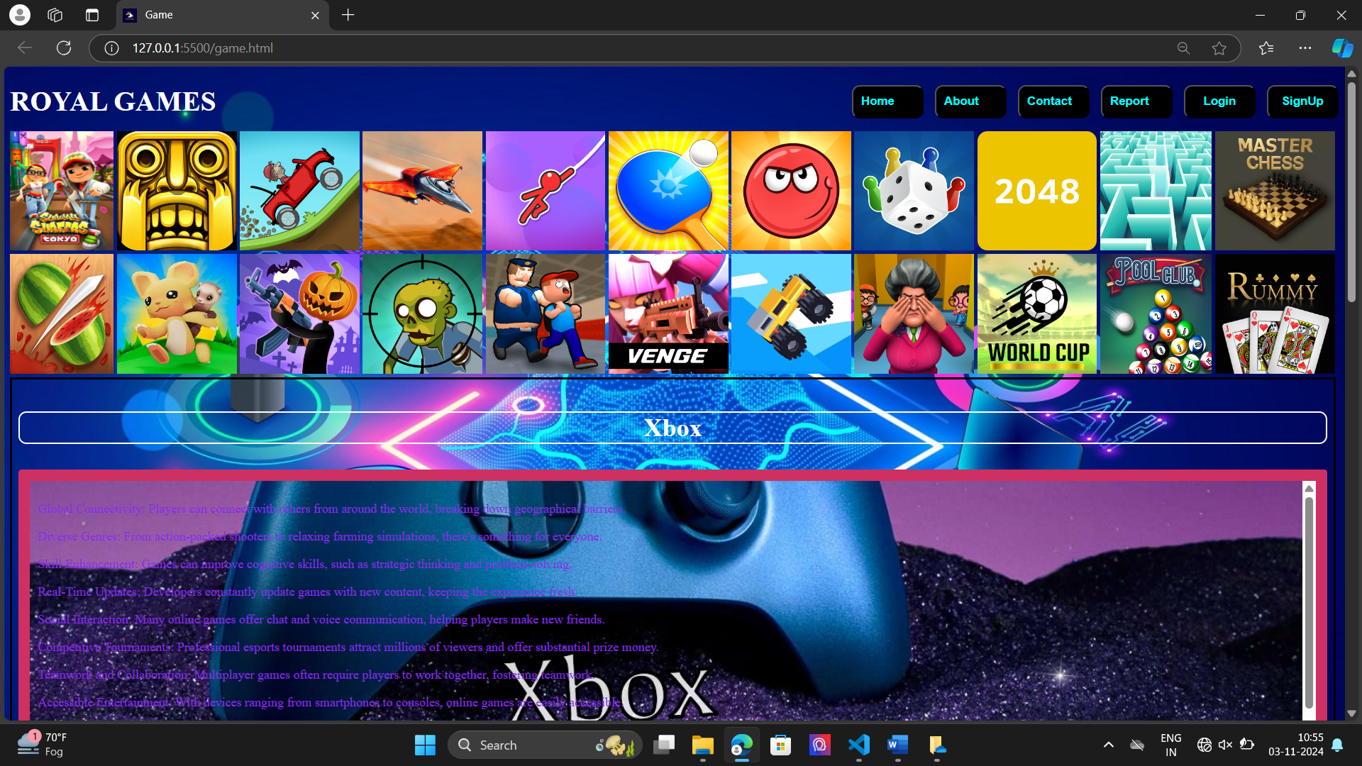 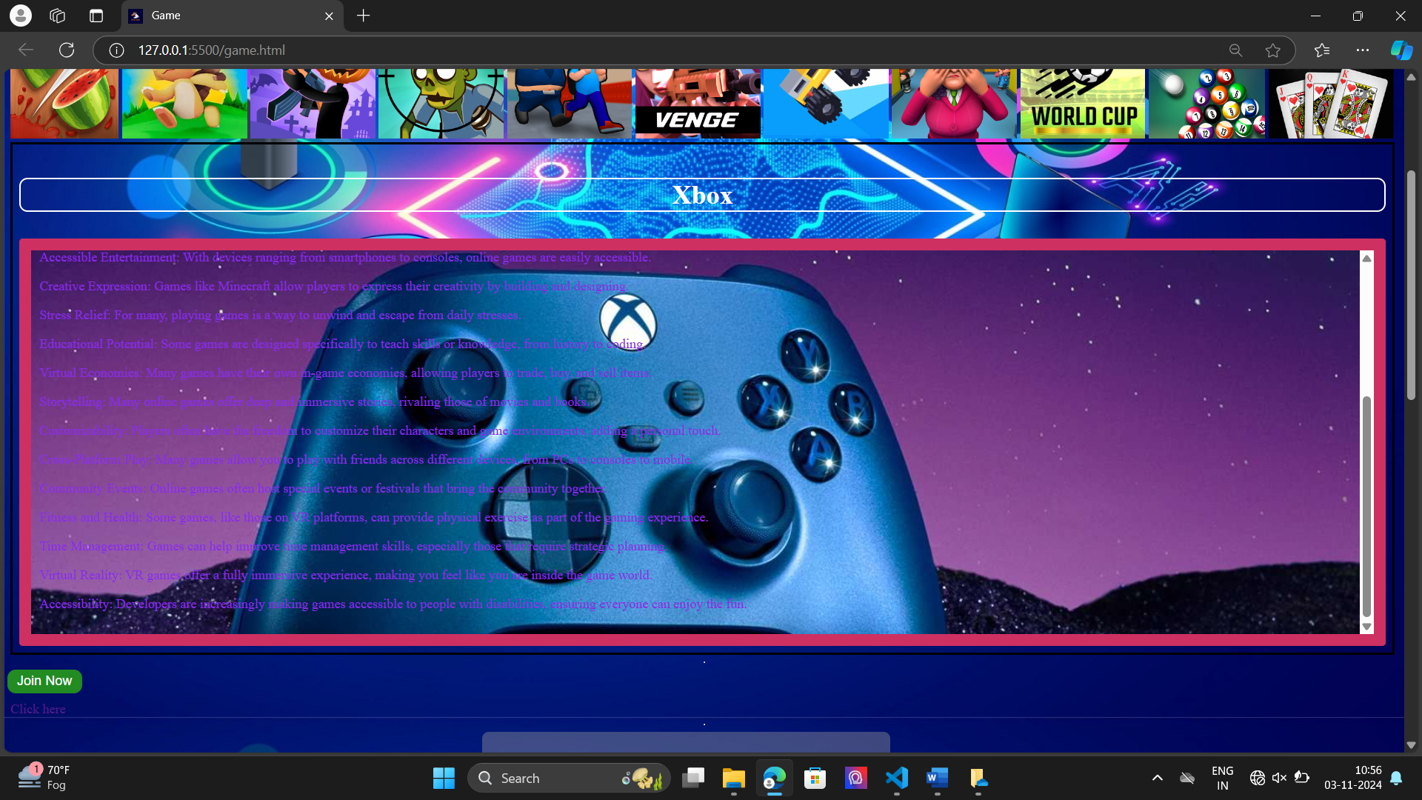 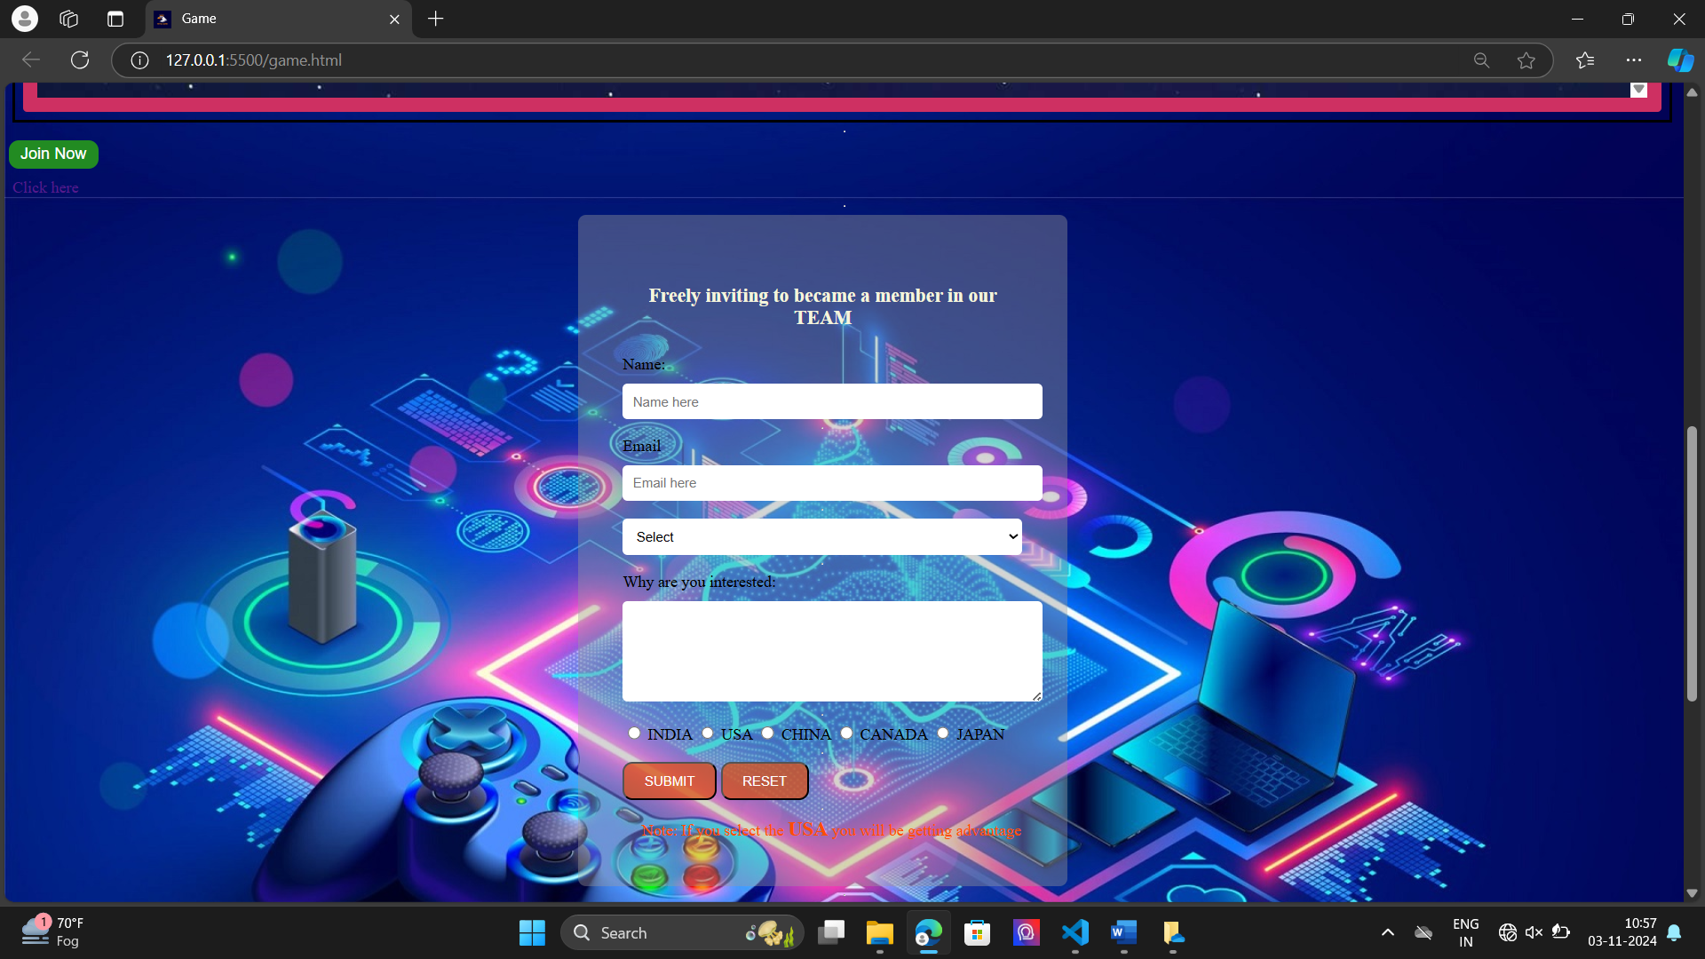 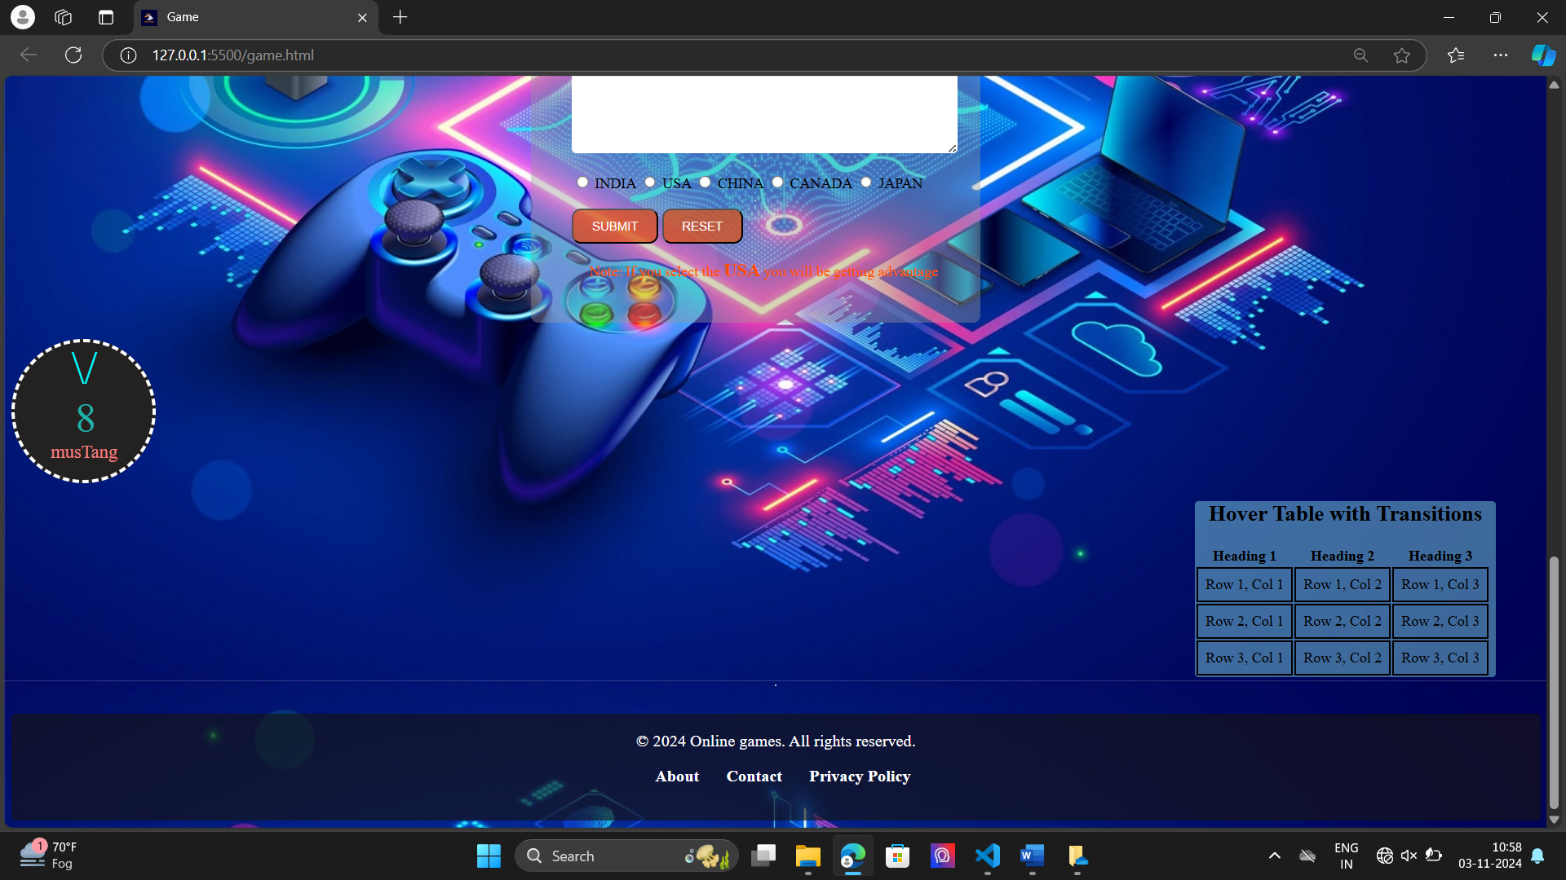

Report.html

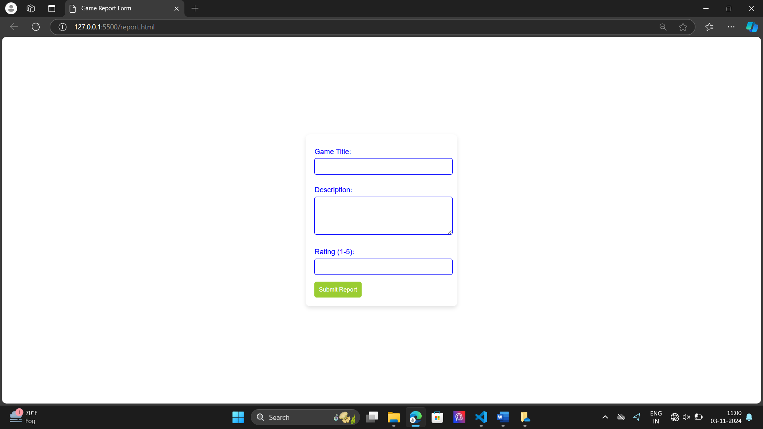

login.html

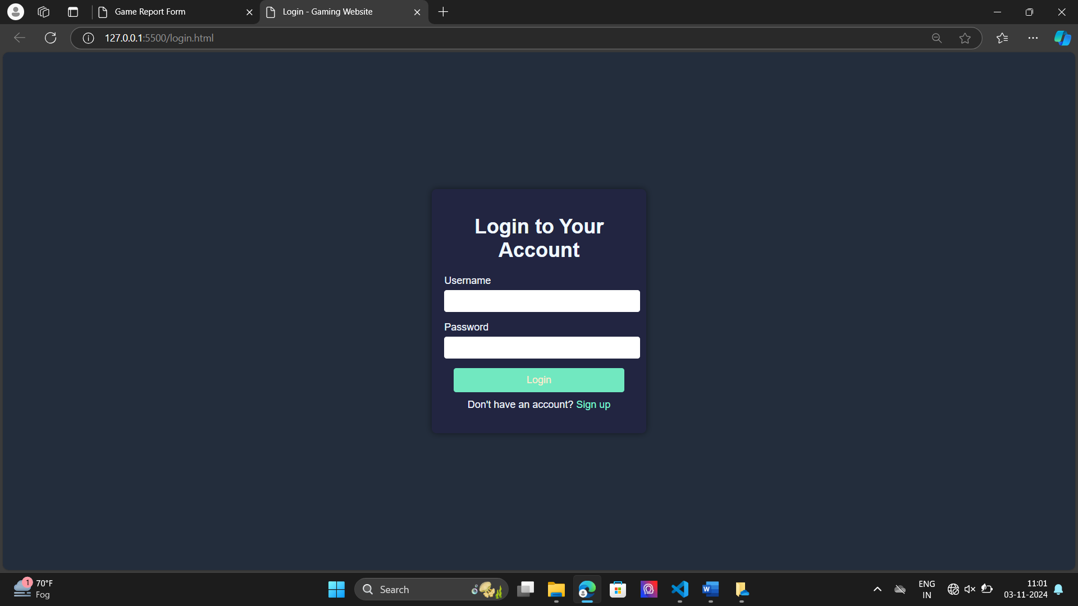

Login2.html

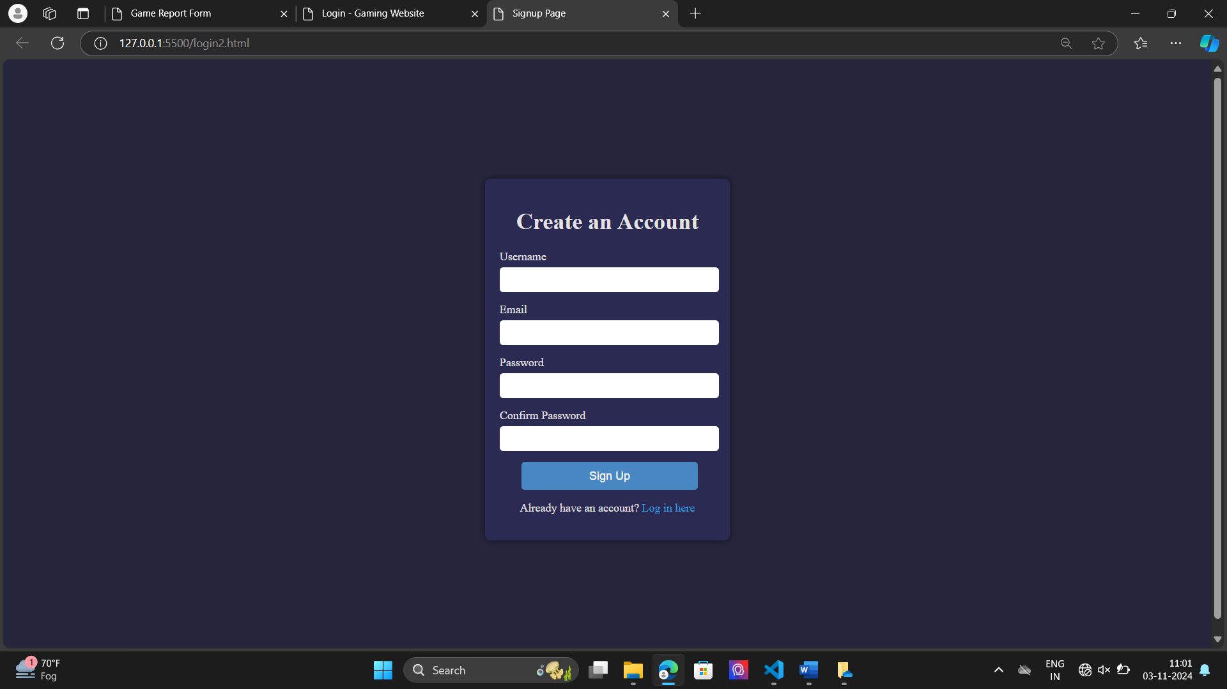

Conclusion: -

The gaming website project using HTML and CSS demonstrates how to build a clean and user-friendly interface for games services or also can take part in the website. By structuring the content with HTML and enhancing the design with CSS, you’ve created a foundational web page that allows users to enter essential details like name, email, interesting game.

References: -

## ➢ W3Schools, GitHub

➢ YouTube, Poki.

Git hub URL:

https://github.com/guthibalasricharan/ROYAL-GAMES

END